AI Manipulation Hackathon
report template

Author name 1  Affiliation | Author name 2  Affiliation | Author name 3  Affiliation
Author name 4  Affiliation | Author name 5  Affiliation | Author name 6  Affiliation
With
Apart Research
Abstract
Write a few paragraphs that concisely and accurately summarize the content of your report, including the results and conclusions. Keep it under 250 words. You are welcome to change the format and content of this template, as long as you stay within the limit.
Lorem ipsum dolor sit amet, consectetur adipiscing elit, sed do eiusmod tempor incididunt ut labore et dolore magna aliqua. Ut enim ad minim veniam, quis nostrud exercitation ullamco laboris nisi ut aliquip ex ea commodo consequat.
Keywords: Multi-agent alignment, AI security, model evaluations, safety infrastructure

Introduction
Agentic-AI systems have improved its sophistication and ability to target IofT, individual consumer devices, and enterprise-grade environments. The October 2025 revelation by Anthropic offered a deeply distributing trend. Agentic-AI has now increased in its sophistication to the point that it can orchestrate mass-level large-scale attacks directed at consumer devices and local development environments. This has created an unprecedented effect on the local consumer market and has created a highly needed new demand of AI-enab;ed sophisticated anti-virus software. It has also created a markedly new shift in consumer demand from tech-savvy individual developers to everyday normal consumers to manipulate, control, and modify their local cyber-security environment in new and changing ways.
However, this has been met with a range of challenges. Firstly, consumer level devices and environments are unlike their enterprise-level counterparts. Limited hardware capacity, coupled with low level understanding of consumers to cyber-architecture, even highly developer-trained individuals, pose unique challenges to this market.
Secondly, using what is known as ‘AI only’ malware detection is both costly and inefficient to run on consumer grade-devices. Regular consumer environments simply do not have the level of RAM, processing power, and generally speaking, computing power to assess massive amounts of surveillance information on a large scale. While individual viral and malware patterned anomalies can be detected using traditional software, no anti-virus software has been developed to allow a consumer-level user to both utilize enterprise level threat-detection capabilities while simultaneously delivering a level of environmental control and customization that is seamless and understandable for the every-day consumer.
Therefore, this project focuses chiefly on the democratization of cyber-security resources to the everyday consumer, coupled with AI to achieve cyber-accessibility. This is the first known research project that focuses on cyber-accessibility through the use of AI and architectural methods to allow for the capabilities of enterprise-level cyber-software to the every-day consumer using AI smartly as a client-sided accessibility interface, and dually, using the ML capabilities of an AI’s LLM for wide-ranging threat detection adapted to the every-day non-technical consumer. It corroborates both the natural language orientation and adaptive capabilities of ML and AI with the traditional infrastructural rules-based and pattern-based capability of enterprise-level anti-virus software adapted into a consumer-level interface channel.

This project explores the use of the Wazuh Open-source Platform to create an adaptive MCP interface for AI-enabled policy manipulation on a local deployment environment.
We have chosen to work on
Write your research question(s) and hypotheses here. Give your free-form writeup of how your work contributes and what your project has been all about! This also provides the answers to multiple questions in the jury evaluation criteria, such as the relevance to the field, the potential impact, and the threat model you work with.

Methods

Write about the methods, code, and Github repositories you made along the way. What type of model did you train, what were your methods, how did you find your way.

Results
Showcase and explain your results here. This is where you include the graphs, screenshots, visualizations, and statistical results from your research.
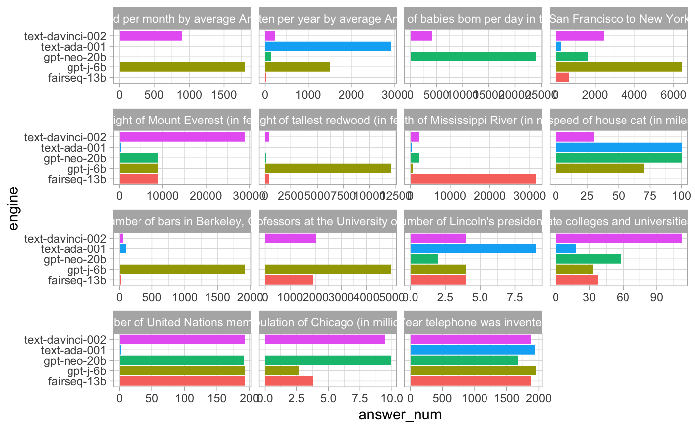
Figure 1 – Representation of benchmarking Number Comprehension Conflation

Discussion and Conclusion
This is where you can include all the wonderful explanations, discussions, results, analyses, statistics, and much more.
Let’s add a few citations: (Alon, 2006; Goh et al., 2021; Lindner et al., 2023; Olah et al., 2020; Weiss et al., 2021). Here, we use the Zotero software with the Zotero add-on for Chrome and Google Docs for citation management but you can also write them manually (for significantly more hassle).

References
Alon, U. (2006). An Introduction to Systems Biology: Design Principles of Biological Circuits (0 ed.). Chapman and Hall/CRC. https://doi.org/10.1201/9781420011432
Goh, G., Cammarata, N., Voss, C., Carter, S., Petrov, M., Schubert, L., Radford, A., & Olah, C. (2021). Multimodal Neurons in Artificial Neural Networks. Distill, 6(3), 10.23915/distill.00030. https://doi.org/10.23915/distill.00030
Lindner, D., Kramár, J., Rahtz, M., McGrath, T., & Mikulik, V. (2023). Tracr: Compiled Transformers as a Laboratory for Interpretability (arXiv:2301.05062). arXiv. http://arxiv.org/abs/2301.05062
Olah, C., Cammarata, N., Schubert, L., Goh, G., Petrov, M., & Carter, S. (2020). Zoom In: An Introduction to Circuits. Distill, 5(3), 10.23915/distill.00024.001. https://doi.org/10.23915/distill.00024.001
Weiss, G., Goldberg, Y., & Yahav, E. (2021). Thinking Like Transformers (arXiv:2106.06981). arXiv. http://arxiv.org/abs/2106.06981

Appendix
Important: Include an appendix called "Security Considerations" that outlines potential limitations of your approach and suggestions for future improvements.

Research conducted at the AI Manipulation Hackathon, 2026

